# 2
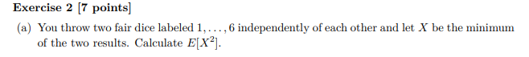
We list the 36 possible outcomes below
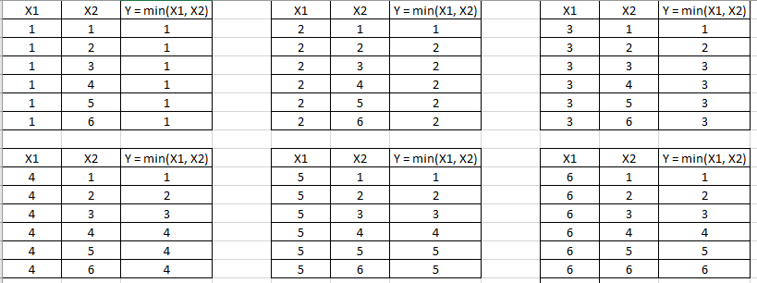

We summarize the table above below
Y = min(X1, X2) | p(y) | y*p(y) | (y^2)*p(y)
1 | 11/36 | 11/36 | 11/36
2 | 9/36 | 18/36 | 36/36
3 | 7/36 | 21/36 | 63/36
4 | 5/36 | 20/36 | 80/36
5 | 3/36 | 15/36 | 75/36
6 | 1/36 | 6/36 | 36/36
 | Total = | 91/36 | 301/36

Therefore,
$E\left[X^{2}\right]=E\left[Y^{2}\right]=\frac{301}{36}$ or 8.361111

Part-b
$$\int_{1}^{k}{3x^{-4}dx={\left.{-x}^{-3}\right|}_{1}^{k}}=1-k^{-3}$$
Solve for k
$$1-k^{-3}=0.5$$
$$k^{-3}=0.5$$
$$k^{3}=2$$
$k=\sqrt[3]{2}$ is the median

# 3
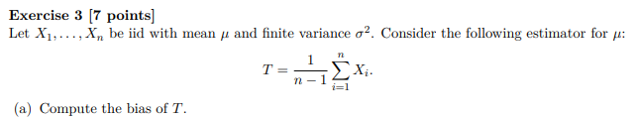
Part-a
$$E\left(T\right)=E\left[\frac{1}{n-1}\sum_{i=1}^{n}{\left(X_{i}\right)}\right]$$
$=\frac{1}{n-1}\sum_{i=1}^{n}{E\left(X_{i}\right)}$
$=\frac{1}{n-1}\sum_{i=1}^{n}{μ}$
$=\frac{nμ}{n-1}$
The bias is
$$E\left(T\right)-μ=\frac{nμ}{n-1}-μ=\frac{μ}{n-1}$$

Part-b
$$Var\left(T\right)=Var\left[\frac{1}{n-1}\sum_{i=1}^{n}{\left(X_{i}\right)}\right]$$

$={\left(\frac{1}{n-1}\right)}^{2}Var\left[\sum_{i=1}^{n}{\left(X_{i}\right)}\right]$
$={\left(\frac{1}{n-1}\right)}^{2}\left[\sum_{i=1}^{n}{Var\left(X_{i}\right)}\right]$ by independence
$={\left(\frac{1}{n-1}\right)}^{2}\left[\sum_{i=1}^{n}{σ^{2}}\right]$
$=\frac{{nσ}^{2}}{{\left(n-1\right)}^{2}}$
The standard error is the square root of Var(T)
Standard error = $\frac{σ\sqrt{n}}{n-1}$

# 4
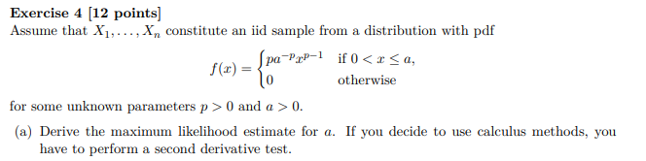
Part-a
The likelihood function is
$$\prod_{i=1}^{n}{f_{X}\left(x_{i}| a\right)}=\left\{\begin{matrix}\prod_{i=1}^{n}{ pa^{-p}x^{p-1} } & if 0≤x_{i}≤a for all i = 1, 2, .., n \\ 0, & elsewhere\end{matrix}\right.$$
$=\left\{\begin{matrix}{\left(\frac{1}{a^{p}}\right)}^{n}p^{n}{\left(\prod_{i=1}^{n}{x_{i}}\right)}^{p-1} & if 0≤x_{i}≤a for all i = 1, 2, .., n \\ 0, & elsewhere\end{matrix}\right.$
${\left(\frac{1}{a^{p}}\right)}^{n}$ is a decreasing function of $a$ so the MLE will be the smallest possible value of $a$ such that
$0≤x_{i}≤a$ for all $i=1, 2, …, n$
Hence, the MLE is ${\hat{a}}_{MLE}=max\left(X_{1},...,X_{n}\right)=X_{\left(n\right)}$which is the maximum order statistic

Part-b
The likelihood is
$$L = p^{n}a^{-np}{\left(\prod_{i=1}^{n}{x_{i}}\right)}^{p-1}$$
The log likelihood is
$$log L = n log p-np log\left(a\right) + \left(p-1\right)\sum_{i=1}^{n}{log \left(x_{i}\right)}$$
$$\frac{∂}{∂p} log L = \frac{n}{p}-n log \left(a\right)+\sum_{i=1}^{n}{log \left(x_{i}\right)} = 0$$
$$\frac{n}{p}=n log \left(a\right)-\sum_{i=1}^{n}{log \left(x_{i}\right)}$$
$$n=p\left[n log \left(a\right)-\sum_{i=1}^{n}{log \left(x_{i}\right)}\right]$$
$$p=\frac{n}{n log \left(a\right)-\sum_{i=1}^{n}{log \left(x_{i}\right)}}$$
Second Derivative Test:
$$\frac{∂^{2}}{∂p^{2}} log L = \frac{-n}{p^{2}}<0$$
Therefore, the MLE of p is
$${\hat{p}}_{MLE}=\frac{n}{n log \left(a\right)-\sum_{i=1}^{n}{log \left(x_{i}\right)}}$$

Part-c
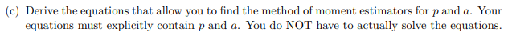
The mean of X is
$$E\left(X\right)=\int_{0}^{a}{pa^{-p}x^{p}dp={\left.\frac{pa^{-p}x^{p+1}}{p+1}\right|}_{x=0}^{x=a}=\frac{pa^{-p}a^{p+1}}{p+1}}=\frac{pa}{p+1}$$
The mean of $X^{2}$ is
$$E\left(X^{2}\right)=\int_{0}^{a}{pa^{-p}x^{p+1}dp={\left.\frac{pa^{-p}x^{p+2}}{p+2}\right|}_{x=0}^{x=a}=\frac{pa^{-p}a^{p+2}}{p+1}}=\frac{pa^{2}}{p+1}$$
The equations to solve are
$$\left\{\begin{matrix}\frac{\sum_{i=1}^{n}{X_{i}}}{n}=\frac{pa}{p+1} \\ \frac{\sum_{i=1}^{n}{{X_{i}}^{2}}}{n}=\frac{pa^{2}}{p+1}\end{matrix}\right.$$

# 5
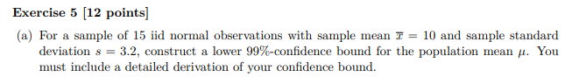
Part-a
$P\left(T>-2.624\right)≈0.99$ based on 14 degrees of freedom
$$P\left(\frac{\overline{X}-μ}{s/\sqrt{n}}<2.624\right)≈0.99$$
$$P\left(μ>\overline{X}-2.624s/\sqrt{n}\right)≈0.99$$
$$P\left(μ>10-2.624\left(3.2\right)/\sqrt{15}\right)≈0.99$$
$$P\left(μ>7.832\right)≈0.99$$
Hence, the 99% confidence interval (lower bound) is (7.832, infinity)

Part-b
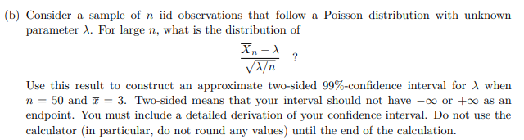
By Central limit Theorem
$\frac{{\overline{X}}_{n}-λ}{\sqrt{λ/n}}$ approximates Normal(0, 1) distribution
$$P\left(\left|Z\right|<2.576\right)≈0.99$$
$$P\left(\left|\frac{{\overline{X}}_{n}-λ}{\sqrt{λ/n}}\right|<2.576\right)≈0.99$$
$$P\left(-2.576<\frac{{\overline{X}}_{n}-λ}{\sqrt{λ/n}}<2.576\right)≈0.99$$
$$P\left(-2.576<\frac{3-λ}{\sqrt{λ/50}}<2.576\right)≈0.99$$
Solve $\frac{3-λ}{\sqrt{λ/50}} =-2.576$ and $\frac{3-λ}{\sqrt{λ/50}} =2.576$
$$P\left(2.43<λ<3.70\right)≈0.99$$
Therefore, the 99% confidence interval is (2.43, 3.70)

# 6
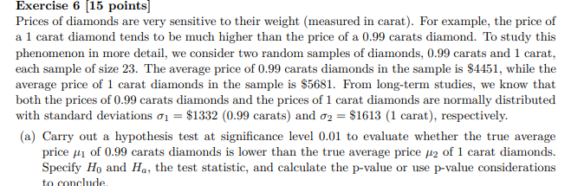
Part-a
The hypotheses are
$$H_{0}:μ_{1}=μ_{2}$$
$$H_{a}:μ_{1}<μ_{2}$$
Test Stat:
$$z=\frac{4451-5681}{\sqrt{\frac{{1332}^{2}}{23}+\frac{{1613}^{2}}{23}}}=-2.82$$
p-value =P(Z < -2.82) = 0.0024
Reject H0 because p-value < 0.01

Part-b

H0 is rejected when Test Stat < -2.326
$P\left(\frac{\overline{X_{1}}-\overline{X_{2}}}{\sqrt{\frac{{1332}^{2}}{23}+\frac{{1613}^{2}}{23}}}>-2.326\right)$ is the Type II error probability
$$P\left(\overline{X_{1}}-\overline{X_{2}}>-2.326\sqrt{\frac{{1332}^{2}}{23}+\frac{{1613}^{2}}{23}}\right)$$

$$P\left(\frac{\left(\overline{X_{1}}-\overline{X_{2}}\right)-\left(4600-5500\right)}{\sqrt{\frac{{1332}^{2}}{23}+\frac{{1613}^{2}}{23}}}>\frac{-2.326\sqrt{\frac{{1332}^{2}}{23}+\frac{{1613}^{2}}{23}}-\left(4600-5500\right)}{\sqrt{\frac{{1332}^{2}}{23}+\frac{{1613}^{2}}{23}}}\right)$$
$$P\left(Z>\frac{-2.326\sqrt{\frac{{1332}^{2}}{23}+\frac{{1613}^{2}}{23}}-\left(4600-5500\right)}{\sqrt{\frac{{1332}^{2}}{23}+\frac{{1613}^{2}}{23}}}\right)$$
$$P\left(Z>-0.26\right)$$
= 1- 0.3974 is the probability of Type II error
= 0.6026 is Type II error probability

Part-c

We want to find n so that
$$P\left(Z>\frac{-2.326\sqrt{\frac{{1332}^{2}}{n}+\frac{{1613}^{2}}{n}}-\left(4600-5500\right)}{\sqrt{\frac{{1332}^{2}}{n}+\frac{{1613}^{2}}{n}}}\right)=0.05$$
Since
$P\left(Z>1.645\right)≈0.05$, we solve

$$\frac{-2.326\sqrt{\frac{{1332}^{2}}{n}+\frac{{1613}^{2}}{n}}-\left(4600-5500\right)}{\sqrt{\frac{{1332}^{2}}{n}+\frac{{1613}^{2}}{n}}}=1.645$$
By trial and error, n is 85.19 so we round up to n = 86

# 7
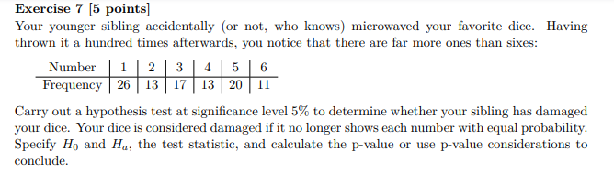
$$H_{0}: The die is fair or p_{1}=p_{2}=p_{3}=p_{4}=p_{5}=p_{6}=1/6$$
$$H_{a}: The die is NOT fair or at least one inequality$$

Observed, O | Expected, E | (O-E)^2/E
26 | 16.6666667 | 5.226667
13 | 16.6666667 | 0.806667
17 | 16.6666667 | 0.006667
13 | 16.6666667 | 0.806667
20 | 16.6666667 | 0.666667
11 | 16.6666667 | 1.926667
 | Total | 9.44

The Test Stat is 9.44 based on k-1 = 6-1 = 5 degrees of freedom
P-value = P(Chi-Square > 9.44) = between 0.05 and 0.10
So we do not reject the null hypothesis.
The die is NOT damaged (Null hypothesis not rejected) based on the result of the hypothesis test

